- INTRODUCTION TO GENERAL REQUIREMENTS
General rules apply related to quality, health, safety, security and the environment (QHSSE) for every site or workshop of QHSSE, irrespective of the tasks the workers are responsible for. These rules must always be respected. If local law are stricter than the requirements of Q8/IDS/TANGO, then the stricter rules must be respected.

- GENERAL HEALTH & SAFETY REQUIREMENTS (HSSE)
CHECK

- SMOKING

  - Smoking is always prohibited on Q8/IDS/Tango locations with exception of areas where it is explicitly allowed (eg smoking area on a construction site)
- DRUGS & ALCOHOL
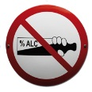
  - Drugs and alcohol are prohibited at all times in Q8/IDS/Tango locations.
  - Employees are not permitted to appear drunk or under the influence of narcotics and drugs in the workplace - when this happens they must immediately be removed from the workplace.

  - The foreman or supervisor (direct superior) of the employee under influence has to remove this employee in an appropriate way from the Q8/IDS/Tango location
- PROTECTIVE EQUIPMENT & CLOTHING

  - wear the recommended or required protective equipment
before entering the site
  - wear additional protective equipment when required for the task
(see other prevention indexes)
  - provide clothing suited to the weather conditions and the nature of the
work, e.g. no loose clothing while working with equipment with
moving parts, warm clothing in winter, ...

- SIGNALISATION OF THE RISK
  - indicate all risk, of any kind , in an appropriate way
  - All risks have to be reported and handled immediately

- TRAFFIC
  - Mark all entrances and exits to sites in a clear way
  - if traffic remains on the station or in the work zone, the workplace must be clearly demarcated and wearing reflective jackets or vests must be worn
  - make sure materials and work do not disrupt traffic around/on/in the site

Examples of good practises

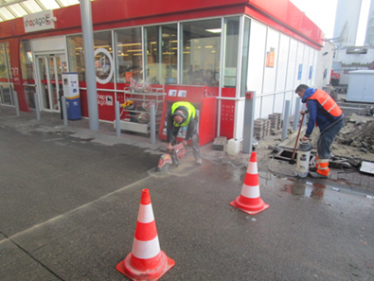
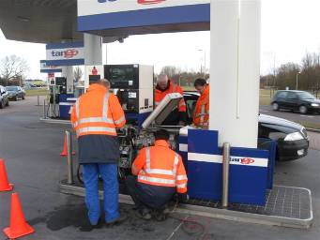

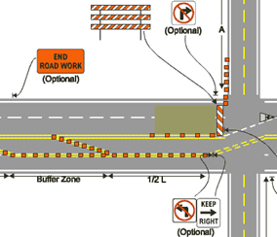

GENERAL HEALTH & SAFETY REQUIREMENTS (HSSE) - continued
CHECK

- NEATNESS AND TIDINESS
  - divide the work location into zones for storing material, tools and waste
  - always keep the area tidy and do not leave obstacles in the way as well for machines as for persons
- LANGUAGES
  - There must always be at least 1 person present who can speak and understand the local language

- GENERAL SAFETY REQUIREMENTS (HSSE)
CHECK

- ACCESS TO THE SITE
  - unauthorised persons may not enter the site
  - close the site off properly when stopping with work
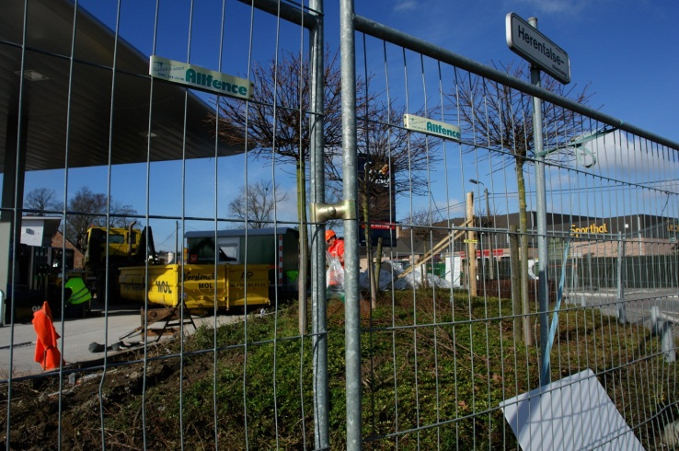



- SURVEILLANCE CAMERAS & IMAGES

  - many sites have monitoring cameras in place conforming to applicable
legislation
  - it is only permitted to images using your own camera,
video camera, mobile phone or any other device after
obtaining permission from the responsible person of Q8/IDS/TANGO
- CRIMINAL EVENTS
  - avoid theft of personal property, materials and tools by keeping them in a place that is not visible.
  - always inform Q8/IDS/TANGO of criminal incidents

- GENERAL ENVIRONMENTAL REQUIREMENTS (HSSE)
CHECK

- WASTE
  - own waste has to be removed/picked up by the relevant contractor
  - industrial waste, household waste and environmentally hazardous products has to be separated and removed as such
  - BE CAREFUL with empty containers of hazardous products -
do not leave them lying around
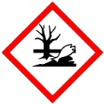

- STORAGE OF HAZARDOUS SUBSTANCES
  - packaging must be properly labelled and product safety sheets consultable
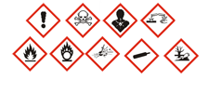
  - the packaging and recipients are always have to be placed on drip trays, in special cabinets or on impermeable floors
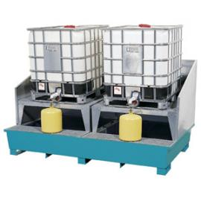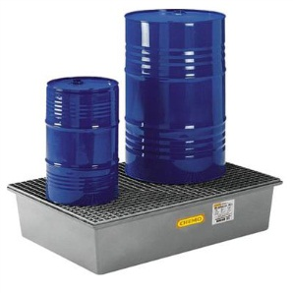
- LIMITED BURDEN ON THE ENVIRONMENT

  - noise pollution, vibrations, odours, light and waste must be limited to absolute requirements
  - Respect the working hours, evening and weekend hours included - do not start too early and end too late

- HSE CRITICAL BARRIERS
* HSE CRITICAL BARRIERS: are technical barriers that are designed to prevent or mitigate emissions of dangerous products. These barriers are essential to safely manage critical processes (= process safety) like storage and transfer of dangerous products or interventions on installations containing these products.
The PSM Barrier Matrix
Examples of HSE Critical Barriers are: tank & piping shells, overfill prevention/protection, alarms/indicators of hydrocarbon detectors, leak detection, vapour recovery systems, hydrocarbon resistant pavements, bunds, KWS.......
Interventions on HSE Critical Barriers are to be considered as ‘high risk’ activities: they can only take place if the necessary precautions are taken. These precautions should be taken during the preparation and the execution of the job and correct follow-up after the intervention should also be guaranteed.
a. Preparation of the job:
- The (job) risk assessment(s) should identify possible interventions on HSE Critical Barriers and the necessary control measures to take for keeping the related (HSE Critical) processes within their predefined safe operating envelope.
During the preparation of the job and in consultation with the process owner, it should be established beforehand:
- On which HSE Critical Barrier(s) and/or parts of it the intervention is to be performed.
- Which processes are controlled by this (these) HSE Critical Barrier(s).
- What the exact function of this (these) HSE Critical Barrier(s) is, what type of HSE Critical barrier it is (are) and what the impact is of the (temporarily) unavailability of this (these) HSE Critical Barrier(s).
- What type of intervention will be performed and which method will be used.
- Which precautions will be taken (e.g. shutdown of a part of the installation), including what to communicate and to whom.
- The required competencies of people performing the intervention and the instructions they should receive. Keep in mind that interventions can be performed internally or by a third party (e.g. certified contractor).
If having a work permit is obliged for the type of job that is planned, the measures subscribed under sub 1 can be taken as part of the process of preparing the work permit.
- Interventions on HSE Critical Barriers should be registered (logbook, work order system …).
- The Last Minute Risk Assessment must always cover the issue of making a HSE Critical Barrier (temporarily) unavailable and the necessary precautions taken.
b. Execution of the job:
- The concerned process owner should supervise the interventions on the HSE Critical Barrier(s). The process owner needs to check if planned control measures are in place and sufficient. The job can only commence/continue if the process owner has satisfied himself that the intervention on the HSE Critical Barrier(s) can take place in a safe way.
c. Follow-up of the job:
- After the job is finished, the process owner needs to decide about the re-commissioning of the HSE Critical Barrier(s). If necessary, tests need to be performed. If a work permit is involved, the process owner needs to enter his written consent on the work permit.

- INCIDENT & ACCIDENTS
CHECK

- ALL INCIDENTS MUST BE REPORTED
  - WHAT: incidents and near misses relating to
health, safety, security and the environment during
work commissioned by Q8/IDS/TANGO
  - WHO: to your employer and Q8/IDS/TANGO
  - WHEN: within 24 hours after the incident
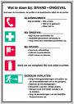
- Preparing for an EMERGENCY

  - emergency plan and instructions for site/yard
(coordinate the emergency plan with various contractors)
  - different scenarios: pollution/leakages,
fire/explosion, first aid, collapse/subsidence, ...
  - immediate notify the emergency services, your own
employer and Q8/IDS/TANGO

- OTHER REQUIREMENTS
CHECK

- DOCUMENTS THAT MUST BE AVAILABLE ON SITE
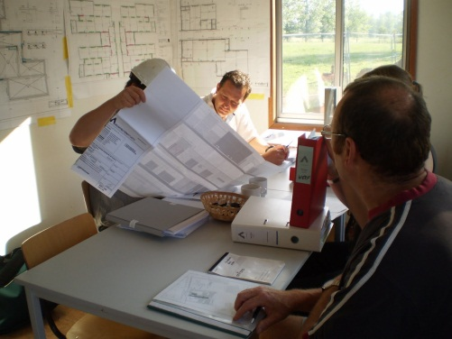
  - worker safety passports
  - Safety, Health and Environment Plan
  - site logbooks
  - valid work permits
  - official permits (building, environment, ...)
  - documentation for material and systems
  - as-built plans

- MANDATORY PARTICIPATION IN SITE MEETINGS
  - start working meeting with safety induction by or on behalf of the main contractor
  - planned site coordination meeting
  - unscheduled meetings, usually after incidents and/or with new contractors
- AVAILABILITY OF CONTACT DETAILS

  - own employer
  - Q8/IDS/TANGO project manager
  - Q8/IDS/TANGO emergency centre for the country
  - responsible person for safety coordination
  - responsible person for environment (if required)
  - emergency numbers (emergency services and utility companies)

- REQUIREMENTS WITH HAZARDOUS TASKS & WORK PERMITS
ADDITIONAL REQUIREMENTS HAVE BEEN PREPARED FOR THE HAZARDOUS TASKS LISTED BELOW AND VALID WORK PERMITS ARE ALWAYS REQUIRED
CHECK

- WORKING AT HEIGHT TSR - Working at Height
Ref: Task Safety Requirements – Working at Height – General
- LADDERS TSR – Ladders
Ref: Task Safety Requirements – Working at Height – Ladders
- MOBILE ELEVATED WORK PLATFORMS TSR – MEWP
Ref: Task Safety Requirements – Working at Height – Mobile Elevated Work Platforms
- SCAFFOLDING TSR – Scaffolding
Ref: Task Safety Requirements – Working at Height – Scaffolding
- ROOF WORK TSR – Roof Work
Ref: Task Safety Requirements – Working at Height – Roof Work
- CONFINED SPACES TSR – Confined Spaces
Ref: Task Safety Requirements – Confined Spaces
- EXCAVATIONS TSR – Excavations
Ref: Task Safety Requirements – Excavations
- HOISTING/LIFTING TSR – Hoisting/Lifting
Ref: Task Safety Requirements – Hoisting and Lifting
- HAZARDOUS SUBSTANCES MEASUREMENTS TSR – Measurements
Ref: Task Safety Requirements – Measurements
- HOT WORK (e.g. welding) TSR – Hot Work
Ref: Task Safety Requirements – Hot Work
- ELECTRICAL INSTALLATIONS TSR – Electrical Installations
Ref: Task Safety Requirements – Electrical Installations

KUWAIT PETROLEUM NORTH WEST EUROPE

DOCUMENT TITLE: TSR - General Requirements

DOCUMENT NUMBER: KPNWE.WI.11.HSCO.039

REVIEW NUMBER: 1

EFFECTIVE DATE: 03 Jul 2020

NEXT REVIEW DATE: 03 Jul 2023
..

CONFIDENTIALITY:
The information contained in this document is confidential to Kuwait Petroleum International Ltd. Copyright © Kuwait Petroleum International Ltd. Copying of this document in any format is not permitted without written permission from the management of Kuwait Petroleum International Ltd.

This document is reviewed and approved according to the released online Document Approval Flow

Prepared by: | Operational Assistant | An Cornelis
Reviewed by: | Operational Assistant | An Cornelis
Approved by: | QHSSE Manager | Gerardus Timmers

*Access rights: Generally Accessible

Reviews Summary

Review date | Review reference | Review details | Review version
01 Dec 2017 |  |  | 0
03 Jul 2020 | -- | minor changes | 1

Each department / unit should appoint its process owners, responsible for the HSE Critical Processes identified within the RIE / PSM evaluations of the concerned department / unit. Process owners can be e.g. operational manager, depot supervisor, key engineering or maintenance functions …

