- INTRODUCTION TO HOT WORK
With welding and grinding safety must come first. With this work there is a risk of radiation, electricity, smoke, explosion and fire. Some of these dangers are "invisible" so extra precautions must be taken.

- EXPLANATION & RISKS
- Definition of "hot work":  - work where an open flame is used welding, roofing, ...  - work where sparks are created grinding, flame cutters, ...  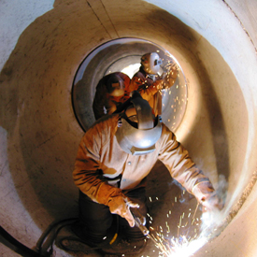  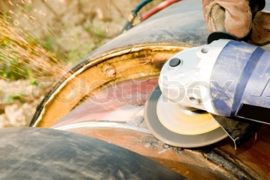 | Examples:  work on pipes  making steel constructions  installation of roof covering
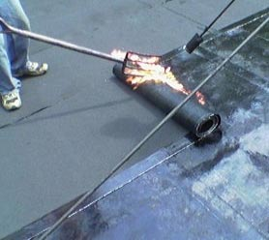

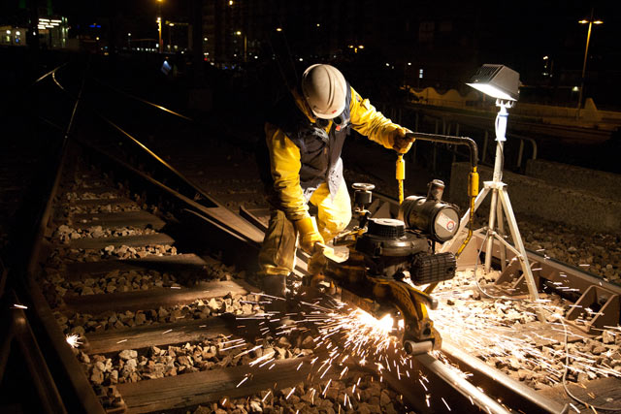

- The following risks are related to hot work:
- Risk of fire/explosion
- Noise induced hearing loss/arc eye
- Electrocution / burning
- Respiratory system/environment affected by the welding by fumes/gases

- SAFETY REQUIREMENTS
ALWAYS: CHECK
- PERSONAL PROTECTIVE EQUIPMENT
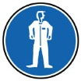
- protective clothing
    - fire retardant

    - welding clothes, if required:
- safety glasses, if needed
    - grinding glasses or goggles when grinding
    - welding glasses; the higher the intensity of the welding flame, the higher the glass number

- safety gloves
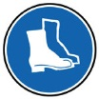
- safety shoes or boots

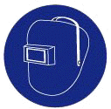
    - with rubber soles and isolated
steel caps for electric welding
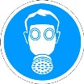
- safety helmet, if necessary (with welding: welding helmet)
- respiratory protection, if necessary
- WORKPLACE PREVENTATIVE MEASURES
- Screen the work area completely off - demarcation
- Provide adequate ventilation
- Cube principle = in an imaginary cube around the workplace:
    - Remove all combustible materials
    - Protect the material that cannot be removed
(e.g. with sheet metal, fire blankets, ...)
    - Use shielding to prevent hot particles ending up in openings in the floor or wall (door, window)
- Always have a fire extinguisher in close proximity
- Provide a welding curtain during electric welding (UV light)
- When stopping work, even for a short period:
    - Extinguish the flame
    - Switch the unit off.
- Additional measures in (the vicinity of) or at:
    - Explosion zones : see TSR - Measurements
    - Confined Spaces : see TSR – Confined Spaces
    - Roof Work: see TSR – Roof Work

ALWAYS:
CHECK
- WELDING
- Make sure that the work material is in a good condition
    - no faults or leaks
    - power and welding cables in a good condition
    - torches and burner ends must be properly cleaned
- Ensure that the underground is dry and isolated when lying or sitting while welding
such as a mat (for the work place also see point C.2. above)
- Hose protection
    - against sharp angles
    - against hard/rough surfaces
    - no vehicles must drive over the hoses
    - no sparks must land on the hoses
- For welding material/surfaces
    - Continuously measure for the presence of flammable products
    - Select the correct electrode, wire or burner tip
- Autogenous welding
    - Additional safety measures while welding with gas supply:
      - Rupture protection at the beginning of the gas pipe
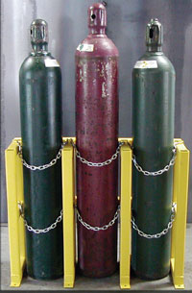
      - Flame terminator between the line and pressure regulator
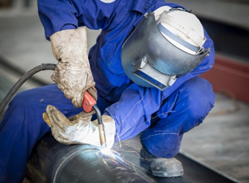
    - Acetylene cylinders:
      - never place horizontally
      - minimum 2 bar cylinder pressure
      - protect against low temperatures
    - Oxygen cylinders:
      - min. 1 meter apart and avoid impacts
      - fasten (against wall or on trolley)
    - Propane: avoid too rapid withdrawal from the cylinder by using larger cylinder rack
    - Storage of gas cylinders
      - Ensure the storage area is well ventilated
      - Store acetylene and oxygen tanks separate from each other
      - Keep empty and full bottles apart from each other
      - Avoid direct exposure to the elements
(no sun)
      - Do not keep oxygen cylinders in cellars or basements
      - Never heat gas cylinders

ALWAYS:
CHECK
- Electric welding:
    - use the lowest possible voltage
    - welding transformer, electrode holder and cables must be insulated
    - when inserting or removing electrodes it is compulsory to use isolating gloves
    - metal chassis or housing of the welding station must be grounded
    - voltage or welding relays mounted in the welding station
    - keep the ambient temperature under control
(humid conditions increase the risk of electrocution)
    - avoid electric welding in confined spaces with metal walls
    - when finished always switch the main switch of the welding station/welding transformer off
- GRINDING
- Prepare well
    - Do not use wet grinding disks; moisture affects the binder
    - Check that the deadman button works properly
    - Use the correct disk; do not trim with a cutting disc
- Grind correctly and safely
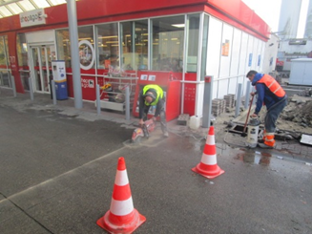
    - Use the correct tools for setting
(wrench and pin spanner)
    - Take in a safe position relative to the disc cutter
    - Hold the disc cutter with both hands; you cannot hold a jumping disc cutter away with only one hand
    - Make sure that the cutting disc is stationary before putting it down
- STAFF TRAINING
    - Operators of equipment must be properly trained
    - Maintenance and replacement of equipment must be done by qualified personnel
- TESTING & INSPECTION
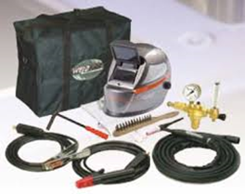
    - Welding accessories: valid periodic inspections in accordance with legal requirements
    - Grinders: periodic internal control with label - by qualified personnel
    - Other equipment monitoring, inspection and labelling in accordance with legal requirements

KUWAIT PETROLEUM NORTH WEST EUROPE

DOCUMENT TITLE: TSR - Hot Work

DOCUMENT NUMBER: KPNWE.WI.11.HSCO.079

REVIEW NUMBER: 1

EFFECTIVE DATE: 06 Jul 2020

NEXT REVIEW DATE: 06 Jul 2023
..

CONFIDENTIALITY:
The information contained in this document is confidential to Kuwait Petroleum International Ltd. Copyright © Kuwait Petroleum International Ltd. Copying of this document in any format is not permitted without written permission from the management of Kuwait Petroleum International Ltd.

This document is reviewed and approved according to the released online Document Approval Flow

Prepared by: | Operational Assistant | An Cornelis
Reviewed by: | Operational Assistant | An Cornelis
Approved by: | QHSSE Manager | Gerardus Timmers

*Access rights: Generally Accessible

Reviews Summary

Review date | Review reference | Review details | Review version
01 Dec 2017 |  |  | 0
06 Jul 2020 | -- | minor changes | 1

